Polynomial interpolation and comparison

Taylor Series Approximation
We can use the first few terms of a Taylor Series to approximating functions
The basic goal of a series is to describe a given complicated quantity as an infinite sum of simple terms; and because the terms get smaller and smaller, we can approximate the original quantity by taking only the first few terms of the series. In this part, we finally create the instrument that allows us to do so in the vast majority of cases: a method for writing any sensible function as an explicit power series. This will allow us to compute function outputs by plugging them into the series. Our functions must act somewhat close to the center of the intended power series. If it is possible to write f(x) = P n=0 cn (xa)n for some coefficients cn, with positive radius of convergence, we say f(x) is analytic at x = a. In practice, any formula containing standard functions and operations defines an analytic function, as long as the formula returns real numbers in a limited interval around x = a.$
Taylor series at$x_{0}$
$$p\left(x\right)=f\left(x_{0}\right)+f^{'}\left(x_{0}\right)\left(x-x_{0}\right)+\frac{f^{''}\left(x_{0}\right)}{2!}{\left(x-x_{0}\right)}^{2}+···$$

Example: Approximation of$f\left(x\right)\text{=}\frac{\text{1}}{x}\text{, }x\text{ ∈ [2,3]}$
– find the$n^{th}$ Taylorpolynomial at $x=2.5$
$$p_{n}\left(x\right)=\frac{1}{2.5}+f^{'}\left(2.5\right)\left(x-2.5\right)+\frac{f^{''}\left(2.5\right)}{2!}{\left(x-2.5\right)}^{2}+\frac{f^{''}'\left(2.5\right)}{3!}{\left(x-2.5\right)}^{3}+···$$

Evaluating the values of the function and its derivatives at $x=2.5$
$$f\left(x\right)=\frac{1}{x}f\left(2.5\right)=\frac{1}{2.5}$$
$$f^{'}\left(x\right)=-\frac{1}{x^{2}}f^{'\left(2.5\right)}=-\frac{1}{{2.5}^{2}}$$
$$f^{''}\left(x\right)=\frac{2}{x^{3}}f^{''\left(2.5\right)}=\frac{2}{{2.5}^{3}}$$
$$f^{'''}\left(x\right)=-\frac{6}{x^{4}}f^{'''\left(2.5\right)}=-\frac{6}{{2.5}^{4}}$$

Therefore, the Taylor polynomials are as follows.
$$p_{0}\left(x\right)=f\left(2.5\right)=\frac{1}{2.5}$$
$$p_{1}\left(x\right)=f\left(2.5\right)+f^{'}\left(2.5\right)\left(x-2.5\right)$$
$$=\frac{1}{2.5}+\left(-\frac{1}{{2.5}^{2}}\right)\left(x-2.5\right)$$
$$=\frac{1}{2.5}-\frac{4}{25}\left(x-2.5\right)$$
$$p_{2}\left(x\right)=p_{1}\left(x\right)+\frac{f^{''}\left(2.5\right)}{2!}{\left(x-2.5\right)}^{2}$$
$$=\frac{1}{2.5}-\frac{4}{25}\left(x-2.5\right)+\frac{1}{{2.5}^{3}}{\left(x-2.5\right)}^{2}$$
$$=\frac{1}{2.5}-\frac{4}{25}\left(x-2.5\right)+\frac{8}{125}{\left(x-2.5\right)}^{2}$$
$$p_{3}\left(x\right)=p_{2}\left(x\right)+\frac{f^{''}'\left(2.5\right)}{3!}{\left(x-2.5\right)}^{3}$$
$$=\frac{1}{2.5}-\frac{4}{25}\left(x-2.5\right)+\frac{8}{125}{\left(x-2.5\right)}^{2}-\frac{16}{625}{\left(x-2.5\right)}^{3}$$

The four figures below compare the graphs of$P_{0}, P_{1}, P_{2},{ P}_{3}$with the graph of$f\left(x\right)=\frac{1}{x}$
Note that near $x=2.5$, the graphs are nearly indistinguishable.

$${ P}_{0}P_{1}$$
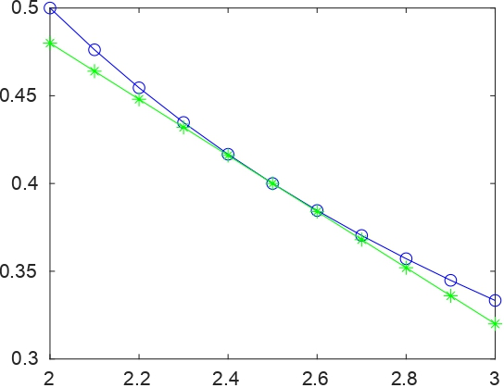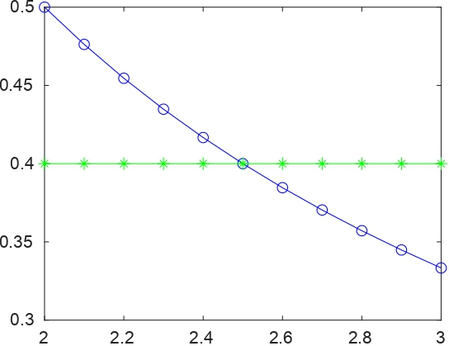

$$P_{2}P_{3}$$
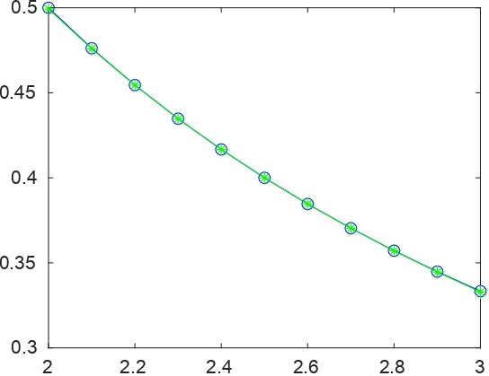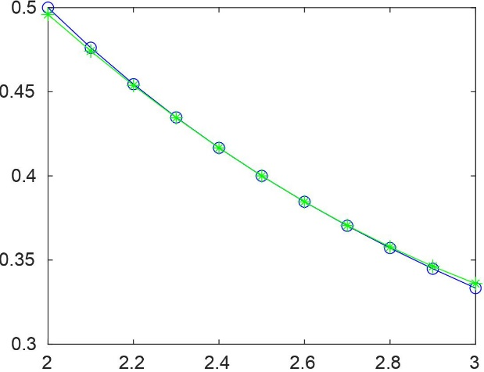

As $n$ increases, the graph of$p_{n}$becomes a better and better approximation of the graph of$f\left(x\right)=\frac{1}{x}$near $x=2.5.$ The Taylor polynomial(x) = 0.4 is just the linear approximation or tangent line of y = sin(x) at the center point x = 0.3. Once they veer apart, the approximation is useless. The next Taylor polynomial = x 3 = x 3 (in green) matches y = sin(x) in its ﬁrst three derivatives at x = 0, and stays close to the original curve up to X < 1. The next Taylor polynomial 3(x) = x 3 (in green) matches y = sin(x) in its ﬁrst three derivatives at x = 0, and stays close to the original curve up to about |x| ≤ 1
– plot$\left|f\left(x\right)-p_{n}\left(x\right)\right|$for $n=0, n=1, n=2,$and$n=3.$
For $n=0$
$$\left|f\left(x\right)-p_{0}\left(x\right)\right|=\left|\frac{1}{x}-\frac{1}{2.5}\right|$$

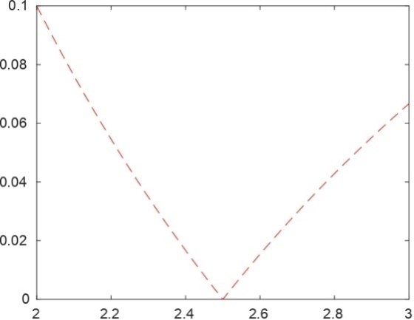
at y= 0.1 the value decrease to 2.5 at the x axis and increase towards right side to 0.06

For$n=1$

$$\left|f\left(x\right)-p_{1}\left(x\right)\right|=\left|\frac{1}{x}-\frac{1}{2.5}-\frac{4}{25}\left(x-2.5\right)\right|$$
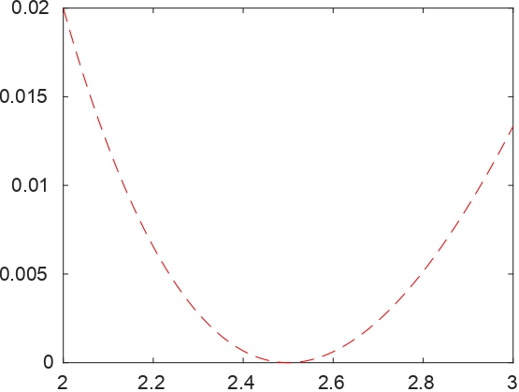

The curve intersect with x-axis at 2.4 and 2.6

For$n=2$
$$\left|f\left(x\right)-p_{2}\left(x\right)\right|=\left|\frac{1}{x}-\frac{1}{2.5}-\frac{4}{25}\left(x-2.5\right)+\frac{8}{125}{\left(x-2.5\right)}^{2}\right|$$
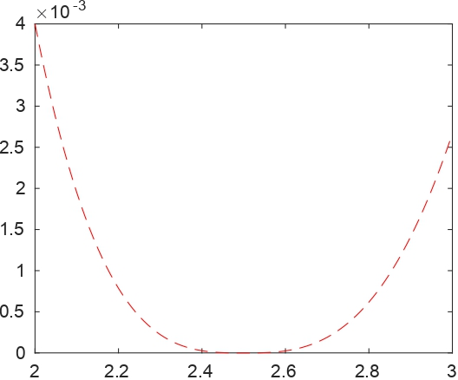
The curve intersect with x-axis at 2.4 and 2.6

For$n=3$
$$\left|f\left(x\right)-p_{3}\left(x\right)\right|=\left|\frac{1}{x}-\frac{1}{2.5}-\frac{4}{25}\left(x-2.5\right)+\frac{8}{125}{\left(x-2.5\right)}^{2}-\frac{16}{625}{\left(x-2.5\right)}^{3}\right|$$
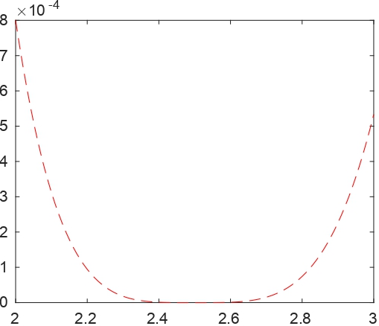

0 The curve intersect with x-axis at 2.4 and 2.6 . at 0.5 on the x axis the value is

–Measure the error at$z=2 :h :3$ with$h= 0.01$, plot the relative error in $2$ norm versusn, where relative error in $2$ norm is

$$E=\frac{\sqrt{\sum_{i=1}^{N}{{\left(f\left(z_{i}\right)-p_{n}\left(z_{i}\right)\right)}^{2}}}}{\sqrt{\sum_{i=1}^{N}{{f\left(z_{i}\right)}^{2}}}}$$

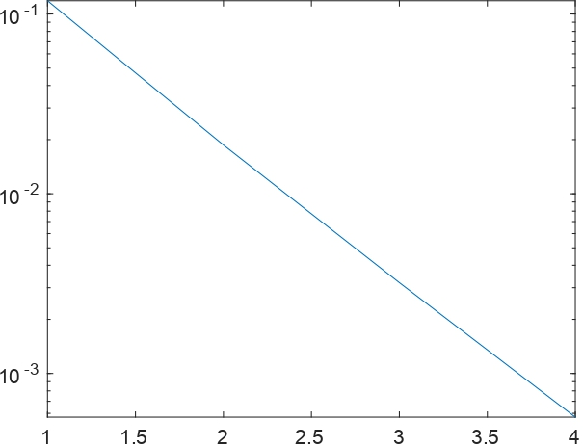

Plot of the relative error in $2$ norm versusn, where relative error in $2$ norm produced a linear line intersecting at x axis at 4 and y axis at 0.01

the gra
Lagrange Polynomials
Lagrange polynomials are used for polynomial interpolation.
InterpolatingPolynomial[data, var] is the Wolfram Language implementation of Lagrange interpolating polynomials. They are employed in the formulation of Newton-Cotes formulae, for example
There is a compromise when creating interpolating polynomials between having a better fit and having a smooth, well-behaved fitting function. The higher the degree of the resulting polynomial, and thus the greater the oscillation between the data points, the more data points are used in the interpolation. As a result, even if the accuracy at the data points is "perfect," a high-degree interpolation may be a poor predictor of the function between points.
The $nth$ Lagrange Integrating Polynomial
$$P\left(x\right)= f \left(x_{0}\right)L_{n,0}\left(x\right)+ · · · + f \left(x_{n}\right)L_{n,n}\left(x\right)=\sum_{k=0}^{n}{f\left(x_{k}\right)L_{n,k}\left(x\right)}$$
where, for each $k=0, 1, …,n,$
$$L_{n,k}\left(x\right)=\frac{(x-x_{0})(x-x_{1})···(x-x_{k-1})(x-x_{k+1})···(x-x_{n})}{(x_{k}-x_{0})(x_{k}-x_{1})···(x_{k}-x_{k-1})(x_{k}-x_{k+1})···(x_{k}-x_{n})}$$

Example:$f\left(x\right)\text{=}\frac{\text{1}}{x}\text{, }x\text{∈}\text{ [2,3]}$
–write down the Lagrange interpolation formula for $n= 2$ and $n= 3.$
For $n=2$
$${ P}_{2}\left(x\right)=\sum_{k=0}^{2}{f\left(x_{k}\right)l_{k}\left(x\right)}=f\left(x_{0}\right){l_{0}\left(x\right)+f\left(x_{1}\right)l}_{1}\left(x\right)+f\left(x_{2}\right)l_{2}\left(x\right)$$

where
$$l_{0}\left(x\right)=\frac{\left(x-x_{1}\right)\left(x-x_{2}\right)}{\left(x_{0}-x_{1}\right)\left(x_{0}-x_{2}\right)}$$
$$l_{1}\left(x\right)=\frac{\left(x-x_{0}\right)\left(x-x_{2}\right)}{\left(x_{1}-x_{0}\right)\left(x_{1}-x_{2}\right)}$$
$${\begin{aligned} \\ l\end{aligned}}_{2}\left(x\right)=\frac{\left(x-x_{0}\right)\left(x-x_{1}\right)}{\left(x_{2}-x_{0}\right)\left(x_{2}-x_{1}\right)}$$

For $n=3$
$${ P}_{3}\left(x\right)=\sum_{k=0}^{3}{f\left(x_{k}\right)l_{k}\left(x\right)}=f\left(x_{0}\right){l_{0}\left(x\right)+f\left(x_{1}\right)l}_{1}\left(x\right)+f\left(x_{2}\right)l_{2}\left(x\right)+f\left(x_{3}\right)l_{3}\left(x\right)$$

where
$$l_{0}\left(x\right)=\frac{\left(x-x_{1}\right)\left(x-x_{2}\right)\left(x-x_{3}\right)}{\left(x_{0}-x_{1}\right)\left(x_{0}-x_{2}\right)\left(x_{0}-x_{3}\right)}$$
$$l_{1}\left(x\right)=\frac{\left(x-x_{0}\right)\left(x-x_{2}\right)\left(x-x_{3}\right)}{\left(x_{1}-x_{0}\right)\left(x_{1}-x_{2}\right)\left(x_{1}-x_{3}\right)}$$
$$l_{2}\left(x\right)=\frac{\left(x-x_{0}\right)\left(x-x_{1}\right)\left(x-x_{3}\right)}{\left(x_{2}-x_{0}\right)\left(x_{2}-x_{1}\right)\left(x_{2}-x_{3}\right)}$$
$$l_{3}\left(x\right)=\frac{\left(x-x_{0}\right)\left(x-x_{1}\right)\left(x-x_{2}\right)}{\left(x_{3}-x_{0}\right)\left(x_{3}-x_{1}\right)\left(x_{3}-x_{2}\right)}$$

– plot$P_{n}\left(x\right)$to approximate $f\left(x\right)\text{ =}\frac{\text{1}}{x}\text{ in [2,3]}$and the error$\left|f\left(x\right)-P_{n}\left(x\right)\right|$
For $n=2,3$

For $n=2$, take $x_{0}=2, x_{1}=2.5, x_{2}=3$
To find theLagrange polynomial of degree 2, first find the value of $l_{0}\left(x\right),l_{1}\left(x\right)$and$l_{2}\left(x\right)$
$$l_{0}\left(x\right)=\frac{\left(x-2.5\right)\left(x-3\right)}{\left(2-2.5\right)\left(2-3\right)}= 2\left(x-2.5\right)\left(x-3\right)$$
$$l_{1}\left(x\right)=\frac{\left(x-2\right)\left(x-3\right)}{\left(2.5-2\right)\left(2.5-3\right)}=-4\left(x-2\right)\left(x-3\right)$$
$${\begin{aligned} \\ l\end{aligned}}_{2}\left(x\right)=\frac{\left(x-2\right)\left(x-2.5\right)}{\left(3-2\right)\left(3-2.5\right)}=2\left(x-2\right)\left(x-2.5\right)$$
also
$$f\left(x_{0}\right)=f\left(2\right)=\frac{1}{2}, f\left(x_{1}\right)=f\left(2.5\right)=\frac{1}{2.5}, f\left(x_{2}\right)=f\left(3\right)=\frac{1}{3}$$
Therefore, theLagrange interpolating polynomial,$P_{2}\left(x\right)$is given by
$$P_{2}\left(x\right)=\left(x-2.5\right)\left(x-3\right)-\frac{8}{5}\left(x-2\right)\left(x-3\right)+\frac{2}{3}\left(x-2\right)\left(x-2.5\right)$$
$$=\frac{1}{15}x^{2}-\frac{1}{2}x+\frac{37}{30}$$
solid line:f(x), given function
dashed line:pn(x), interpolating polynomial

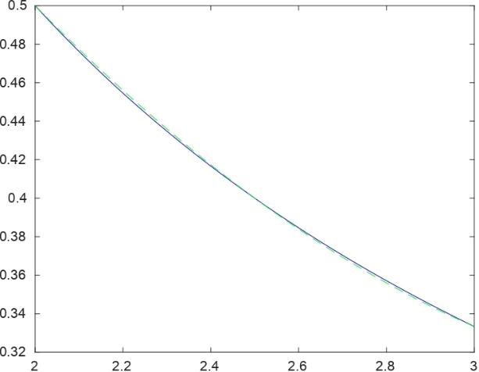

Theerror$\left|f\left(x\right)-P_{2}\left(x\right)\right| is$
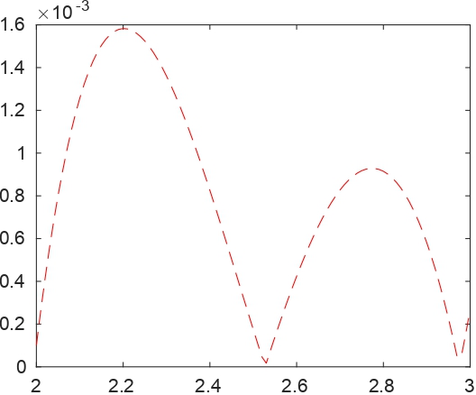
The curve interlocks with the a-axis at 0, 2.5 and 3

For $n=3$, take${ x}_{0}=2,x_{1}=2+1/3, x_{2}=2+2/3, x_{3}=3$
To find theLagrange polynomial of degree 3, first find the value of $l_{0}\left(x\right),l_{1}\left(x\right),l_{2}\left(x\right)$and$l_{3}\left(x\right)$
$$l_{0}\left(x\right)=\frac{\left(x-\frac{7}{3}\right)\left(x-\frac{8}{3}\right)(x-3)}{\left(2-\frac{7}{3}\right)\left(2-\frac{8}{3}\right)(2-3)}=-\frac{9}{2}\left(\left(x-\frac{7}{3}\right)\left(x-\frac{8}{3}\right)(x-3)\right)$$
$$l_{1}\left(x\right)=\frac{\left(x-2\right)\left(x-\frac{8}{3}\right)(x-3)}{\left(\frac{7}{3}-2\right)\left(\frac{7}{3}-\frac{8}{3}\right)\left(\frac{7}{3}-3\right)}=\frac{27}{2}\left(\left(x-2\right)\left(x-\frac{8}{3}\right)(x-3)\right)$$
$$l_{2}\left(x\right)=\frac{\left(x-2\right)\left(x-\frac{7}{3}\right)(x-3)}{\left(\frac{8}{3}-2\right)\left(\frac{8}{3}-\frac{7}{3}\right)\left(\frac{8}{3}-3\right)}=-\frac{27}{2}\left(\left(x-2\right)\left(x-\frac{7}{3}\right)(x-3)\right)$$
$$l_{3}\left(x\right)=\frac{\left(x-2\right)\left(x-\frac{7}{3}\right)\left(x-\frac{8}{3}\right)}{\left(3-2\right)\left(3-\frac{7}{3}\right)\left(3-\frac{8}{3}\right)}=\frac{9}{2}\left(\left(x-2\right)\left(x-\frac{7}{3}\right)\left(x-\frac{8}{3}\right)\right)$$
also
$$f\left(x_{0}\right)=f\left(2\right)=\frac{1}{2}, f\left(x_{1}\right)=f\left(\frac{7}{3}\right)=\frac{3}{7}, f\left(x_{2}\right)=f\left(\frac{8}{3}\right)=\frac{3}{8}, f\left(x_{3}\right)=f\left(3\right)=\frac{1}{3}$$
Therefore, theLagrange interpolating polynomial,$P_{3}\left(x\right)$is given by
$$P_{3}\left(x\right)=\frac{9}{4}\left(\left(x-\frac{7}{3}\right)\left(x-\frac{8}{3}\right)\left(x-3\right)\right)+\frac{81}{14}\left(\left(x-2\right)\left(x-\frac{8}{3}\right)\left(x-3\right)\right)-\frac{81}{16}\left(\left(x-2\right)\left(x-\frac{7}{3}\right)\left(x-3\right)\right)+\frac{3}{2}\left(\left(x-2\right)\left(x-\frac{7}{3}\right)\left(x-\frac{8}{3}\right)\right)$$

$$=-\frac{3}{112}x^{3}+\frac{15}{56}x^{2}-\frac{335}{336}x+\frac{275}{168}$$
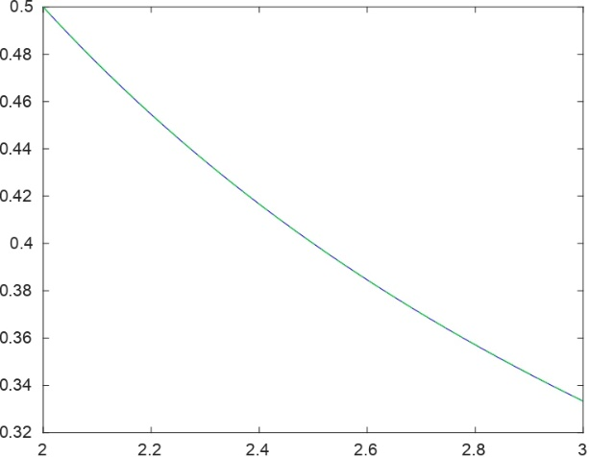
The p3 value produced a curve that did not intersect with the a-axis

Theerror$\left|f\left(x\right)-P_{3}\left(x\right)\right| is$
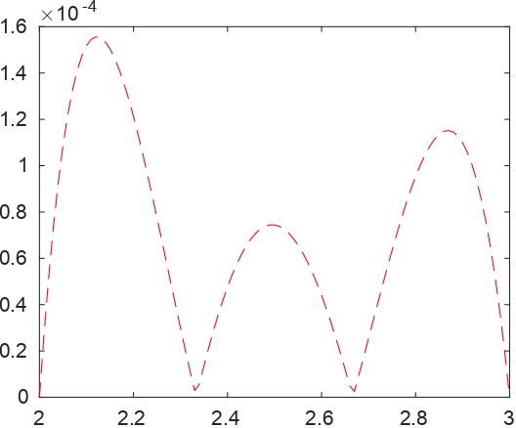

The curve interlocks with the a-axis at 0, 2.5 and 3

–plot relative error versusn
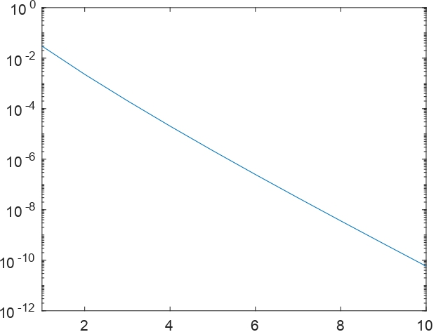

The graph does not intersect with the X-axis but it intersect with y –axis at 0.001

Interpolation at the uniform points and Chebyshev points
It is generally known that the zeros of Chebyshev polynomials in one variable are in many ways ideal nodes for polynomial interpolation; see, for example.For n1, the Chebyshev polynomial of degree n is defined as
Polynomial interpolation presents numerous challenges with multiple variables. To begin, in order to ensure that interpolation issues are well-posed, an appropriate subspace of polynomials in which the interpolation polynomial can be uniquely chosen must be found for each given collection of points.
$$- f\left(x\right)\text{=}\frac{\text{1}}{x}\text{, }x\text{∈}\text{ [2,3]}$$

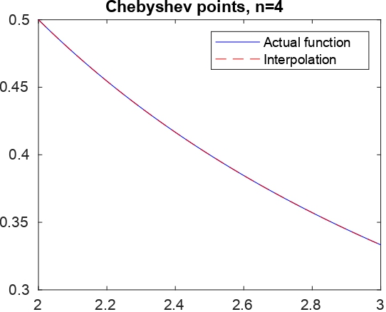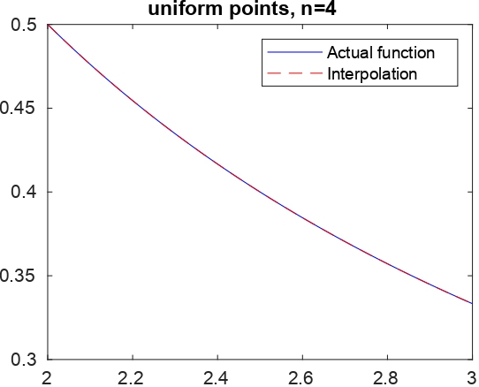

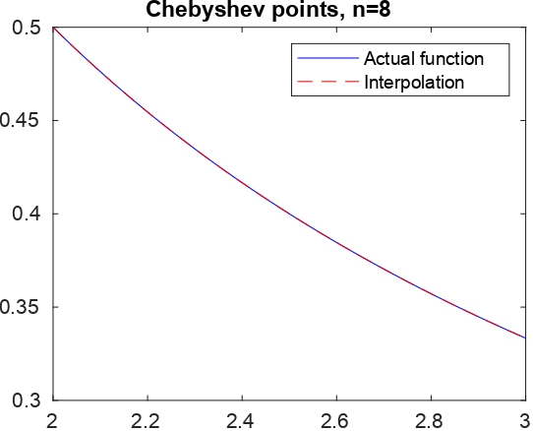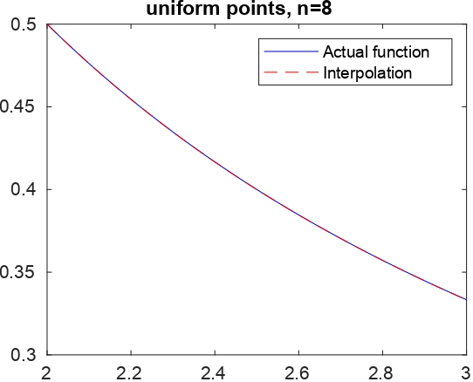

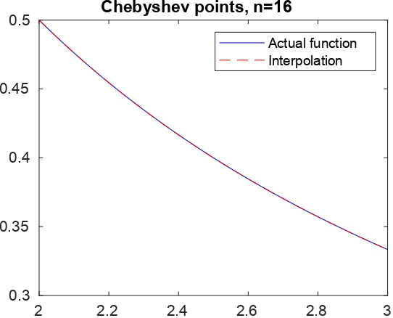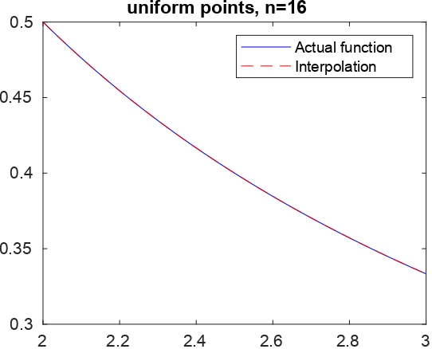
When the uniform points were plotted the curve curves inwards while the chebyshev its curves outwards

Other Functions
For a continuous distribution, the uniform distribution defines equal probability over a given range. As a result, it is significant as a reference distribution. The production of random numbers is one of the most important uses of the uniform distribution.
Chebyshev polynomials are essential in approximation theory because the roots of Tn(x), also known as Chebyshev nodes, are utilized as matching points in polynomial interpolation. The resulting interpolation polynomial minimizes the Runge's phenomenon problem and offers an approximation to a continuous function that is close to the best polynomial approximation under the maximum norm, often known as the "minimax" criterion.
$$f\left(x\right)=x^{20} , -1≤x≤1$$

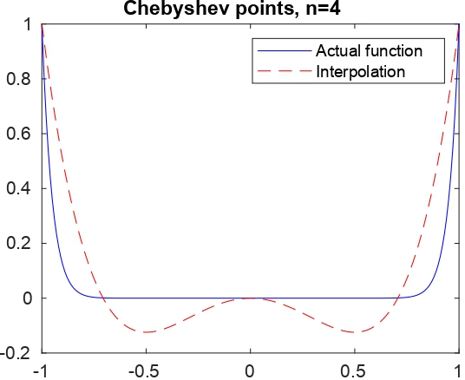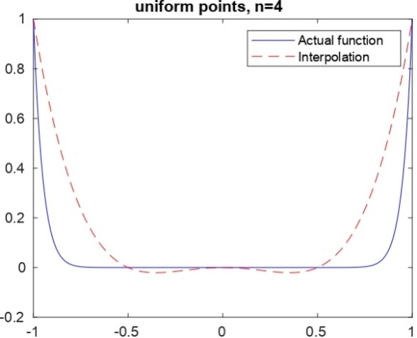

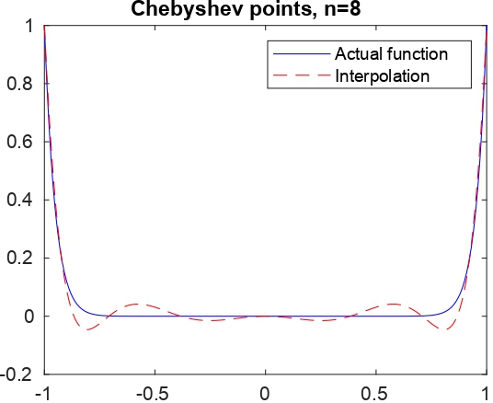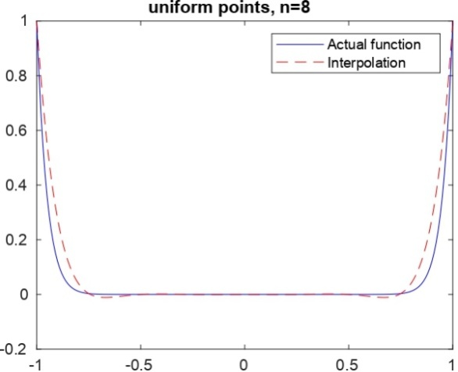

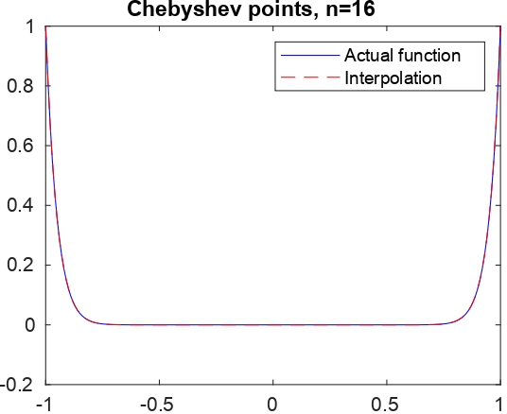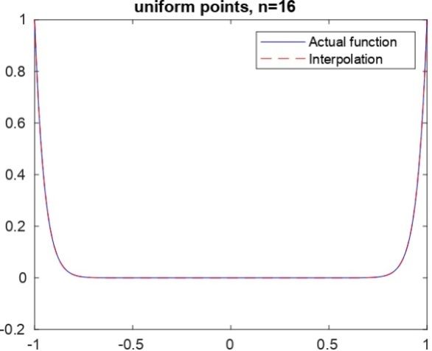

The non-smooth function (top) y = −x³H(−x), where H is the Heaviside step function, and (bottom) the 5th partial sum of its Chebyshev expansion. The 7th sum is indistinguishable from the original function at the resolution of the graph.

$$f\left(x\right)=e^{x} , -1≤x≤1$$

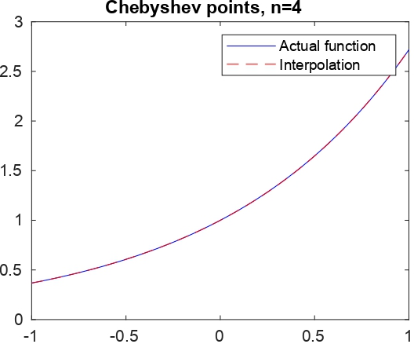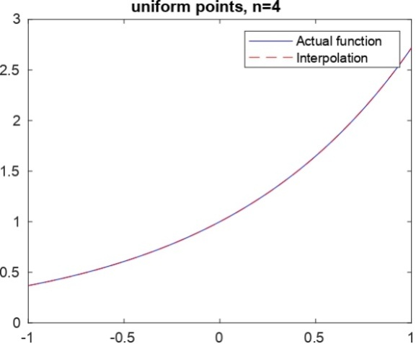

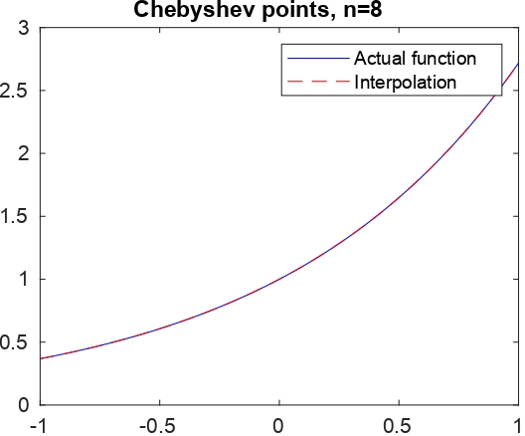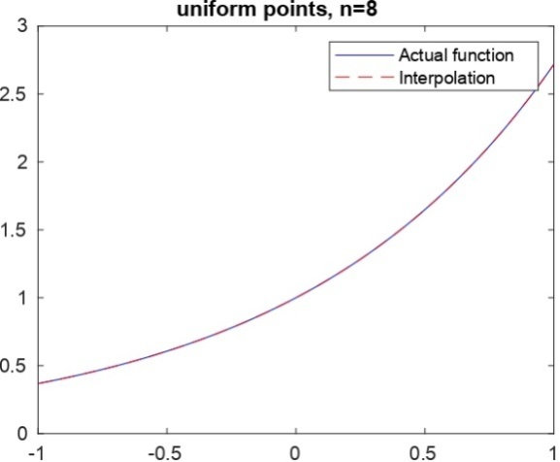

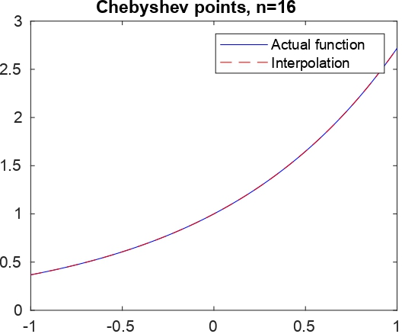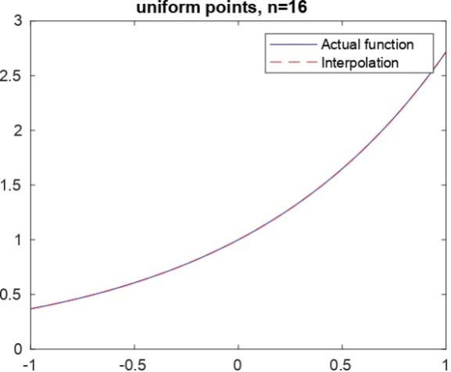

The curve for the actual function intersect y axis for both n = 16 and n=8 at 0.4

$$f\left(x\right)=e^{{-x}^{2}} , -1≤x≤1$$

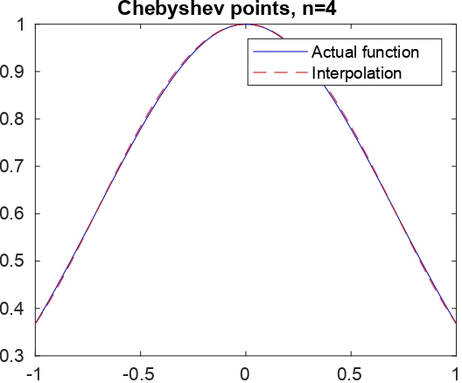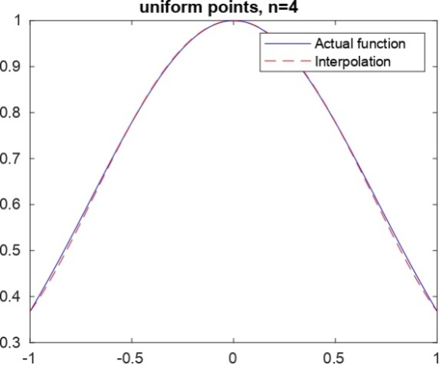

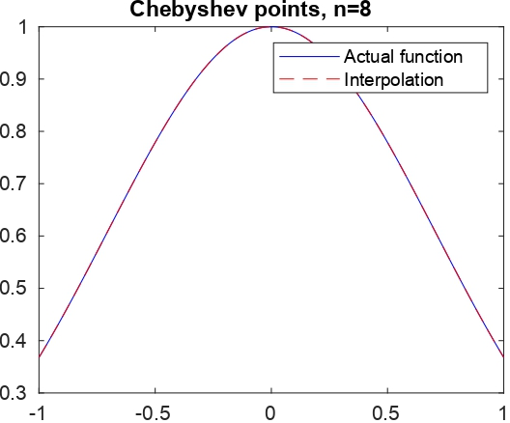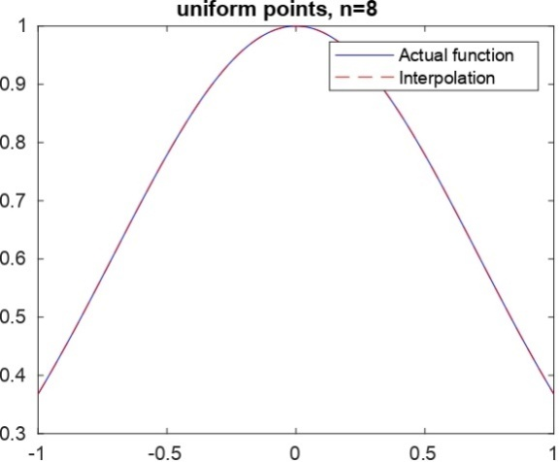

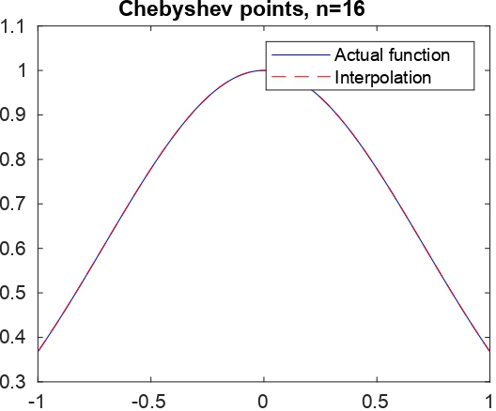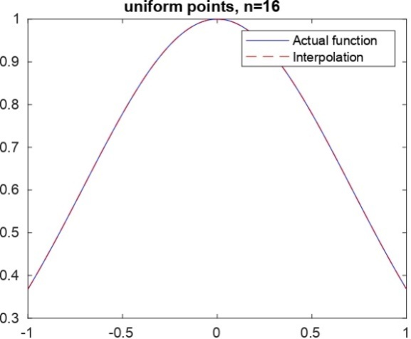

The curve for the actual function intersect y axis for both n = 16 and n=8 at 0.45 and the maximum value for the curve is at the 1

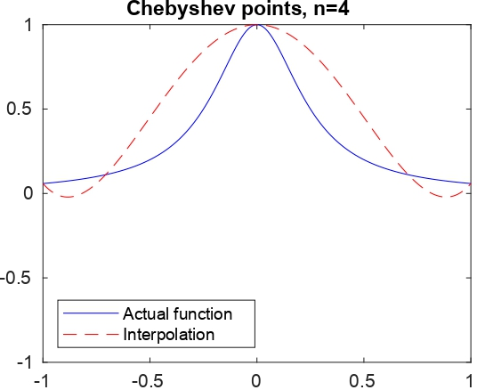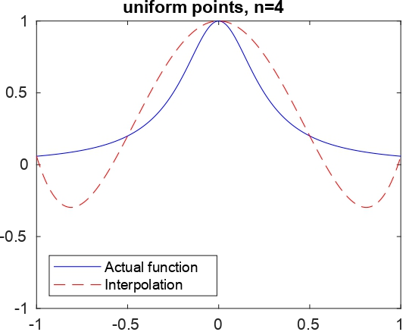

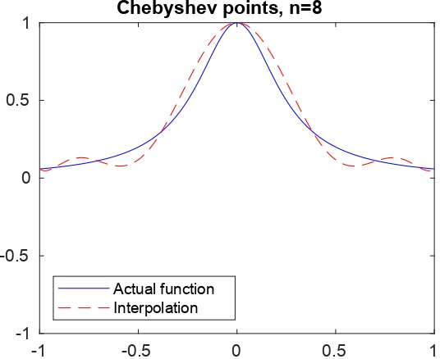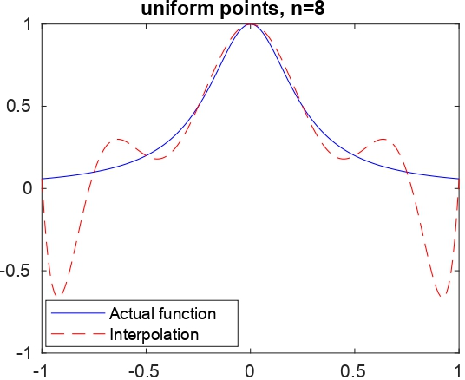

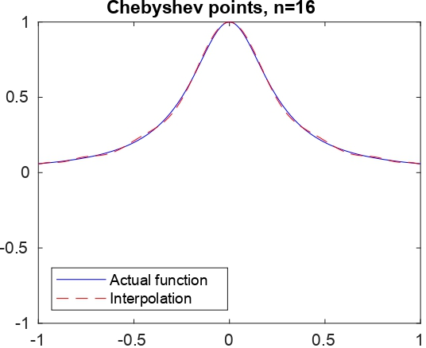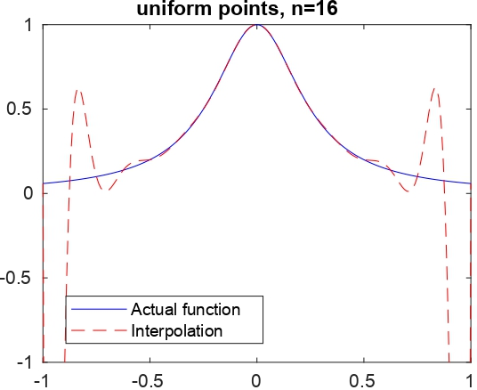

On the left we have a general panoramic of the interpolation along T and we have added the interpolation points in green. We must point up that the interpolatory process is successful where the function has no variability. However, we have an unsuccessful situation where the function has great variability.

$$f\left(x\right)=e^{-1/x^{2}} , -1≤x≤1$$

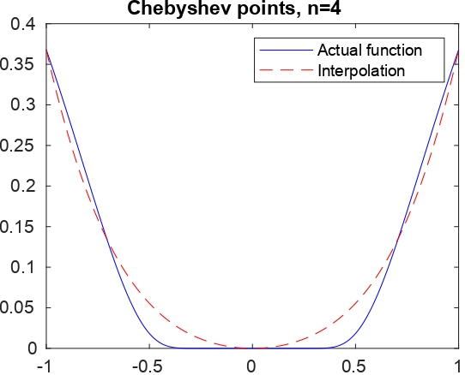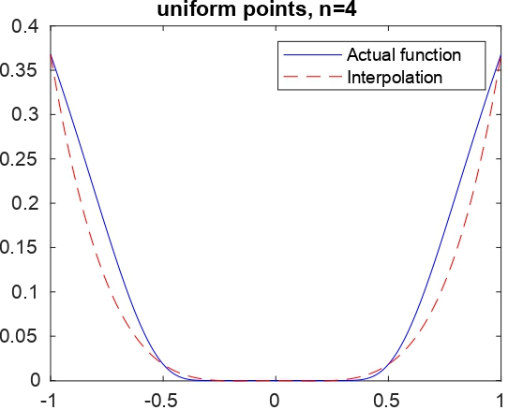

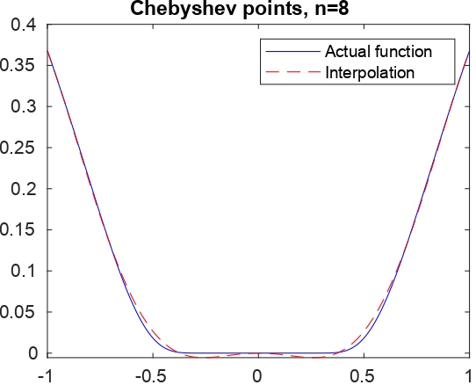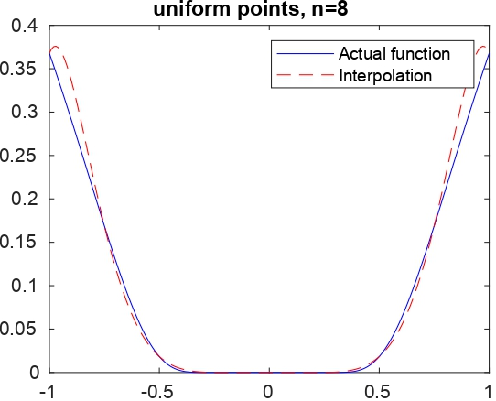

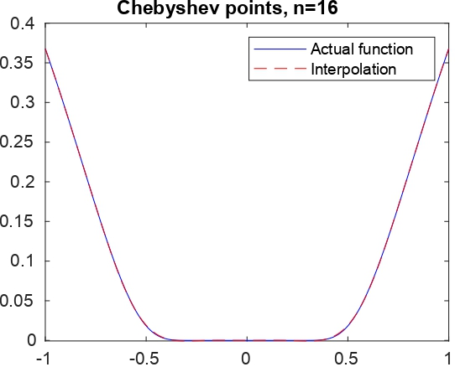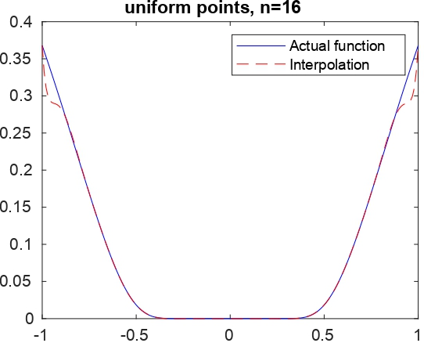
The curve for the interpolation is high than actual function for uniform point intersect x axis on -0.5 and 0.5 for n=8 and at y – axis at 0.35. for the curves for chebyshev intersect at – 0.5 and 0.5 at the axis and y –axis for both uniform points and chebyshev points

$$f\left(x\right)={\left|x\right|}^{3} , -1≤x≤1$$

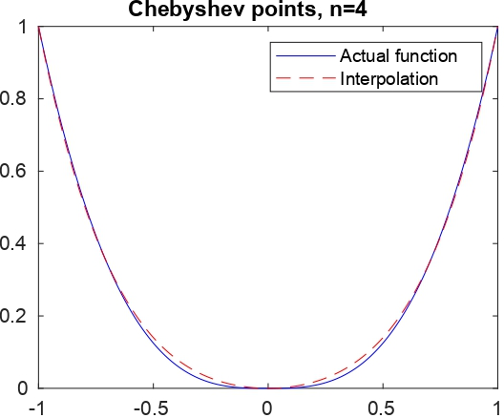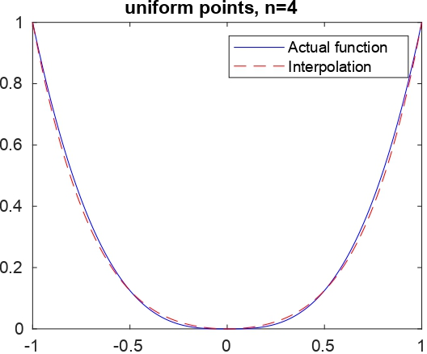

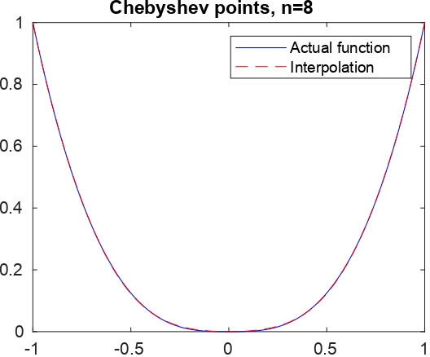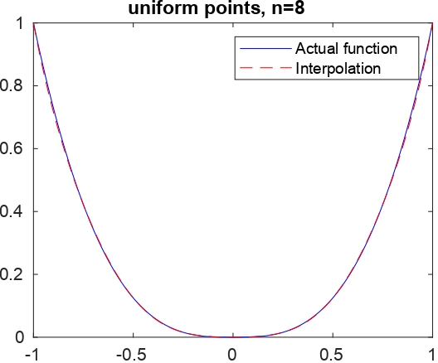

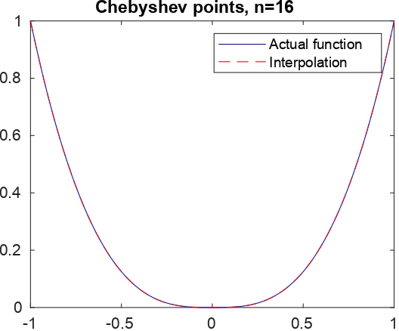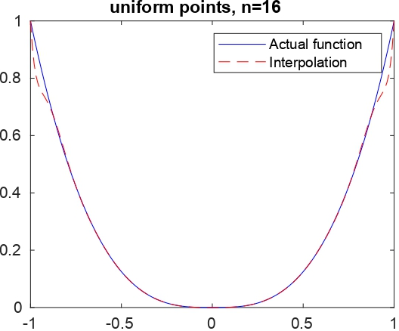
We plot on the left F(eiθ) and R(L−n,n−1(F,eiθ)) for θ∈[0,2π] and n=60. Notice that they are indistinguishable. On the right we plot the errors given by R(L−n,n−1(F,eiθ))−F(eiθ) with θ∈[0,2π]. We point out that the errors are less or equal

